RAJALAKSHMI ENGINEERING COLLEGE
An Autonomous Institution, Affiliated to Anna University
Rajalakshmi Nagar, Thandalam – 602 105

WEB TECHNOLOGY AND MOBILE APPLICATION
Experiment – 02
2025-26

By
NIJANTHAN V
B-TECH AI&DS
2116241801185

Expt.NO: 02 DATE:

Write JavaScript Programme to validate the following fields of the HTML Registration page.

AIM:
To write JavaScript code to validate user input in a registration form. The validation will ensure that the data entered by the user meets specific criteria for each field. This will help in maintaining data integrity and prevent invalid submissions.

ALGORITHM:
1. Input:
- The user fills in the following fields: First Name, Password, E-mail, Mobile Number, Last Name, and Address.
2. Validation Steps:
- Validate First Name:
  - Check if the first name contains only alphabets.
  - Ensure the length of the First Name is at least 6 characters.
  - If any of these conditions fail, display an error message indicating the required input.
- Validate Password:
  - Check if the password is at least 6 characters long.
  - If it is less than 6 characters, display an error message.
- Validate E-mail:
  - Use a regular expression to check if the email follows the standard pattern: name@domain.com.
  - Ensure that the email contains no invalid characters and matches the required pattern.
  - If it doesn't match, display an error message indicating an invalid email format.
- Validate Mobile Number:
  - Check if the mobile number contains exactly 10 digits.
  - Ensure there are no alphabets or special characters.
  - If the number is invalid, display an error message indicating the correct format.
- Validate Last Name:
  - Ensure the Last Name field is not empty.
  - If it is empty, display an error message.
- Validate Address:
  - Ensure the Address field is not empty.
  - If it is empty, display an error message.
- Validate Address:
  - Ensure the Address field is not empty.
  - If it is empty, display an error message.
CODE:
function loginAlert() {

let isValid = true;

// Get values
let fname = document.getElementById("fname").value.trim();
let lname = document.getElementById("lname").value.trim();
let password = document.getElementById("password").value;
let email = document.getElementById("email").value.trim();
let mobile = document.getElementById("mobile").value.trim();
let address = document.getElementById("address").value.trim();

// Clear previous errors
document.querySelectorAll(".error").forEach(e => e.innerHTML = "");

// 1. First Name Validation
let namePattern = /^[A-Za-z]+$/;
if (!namePattern.test(fname)) {
document.getElementById("fnameError").innerHTML = "First name must contain only alphabets";
isValid = false;
} else if (fname.length < 6) {
document.getElementById("fnameError").innerHTML = "First name must be at least 6 characters";
isValid = false;
}

// 2. Password Validation
if (password.length < 6) {
document.getElementById("passwordError").innerHTML = "Password must be at least 6 characters long";
isValid = false;
}

// 3. Email Validation
let emailPattern = /^[^\s@]+@[^\s@]+\.[^\s@]+$/;
if (!emailPattern.test(email)) {
document.getElementById("emailError").innerHTML = "Invalid email format";
isValid = false;
}

// 4. Mobile Number Validation
let mobilePattern = /^[0-9]{10}$/;
if (!mobilePattern.test(mobile)) {
document.getElementById("mobileError").innerHTML = "Mobile number must be exactly 10 digits";
isValid = false;
}

// 5. Last Name Validation
if (lname === "") {
document.getElementById("lnameError").innerHTML = "Last name cannot be empty";
isValid = false;
}

// 6. Address Validation
if (address === "") {
document.getElementById("addressError").innerHTML = "Address cannot be empty";
isValid = false;
}

return isValid;
}

Output:

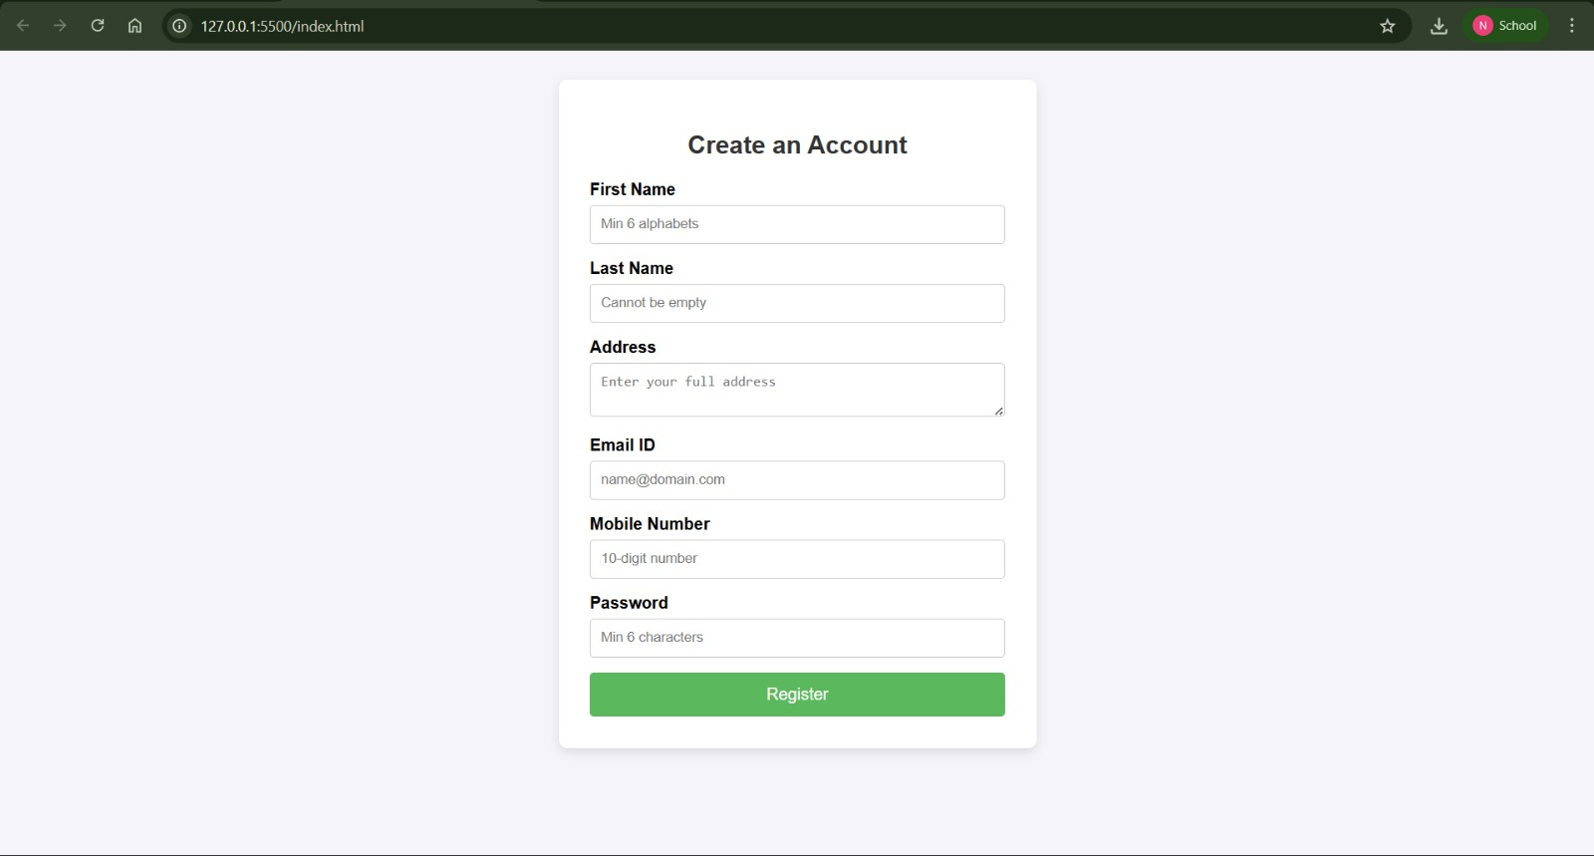

RESULT:
HTML page with Form is created and is validated using Javascript

